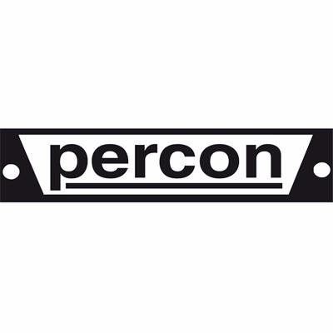

Press Release
Barcelona, 31 August 2018

PERCON & AVP: News for 2018
Percon is pleased to introduce the latest news about our products at the IBC Show in Amsterdam 2018.
First of all, the innovative SILVER+ EMC cables. The new EMC system provides the cable with greater electromagnetic immunity (S = R + A + M)> 20db, which is especially suitable for installations with high density of wiring. This, along with the higher CU + Al density of the general shield, makes this range of cables one of the best in the market against electromagnetic interferences, keeping the same composition of the successful SILVER + cables:
- Silver-plated copper central conductor with lower attenuation (6,5%)
- Greater propagation speed (85%)
- 4K transmission
It is noteworthy to mention that all PERCON comply with the new CPR (Construction Product Regulation), including improvements regarding resistance to fire and dangerous substances used in the building sector.
In addition, Percon will be launching the new line of high performance 75 ohm BNC UHD/8K with black body and internal and external gilded contacts, with standard crimping sizes.
Last but not least, special mention top other of our latest news will be the AW8K line of 4K and 8K video patch panels from our AVP partners, with low return loss and 75 ohm impedance.
Enjoy your visit to IBC 2018! We will be delighted to meet you at our stands 10. E51 & 10. E52.

PERCON
C/Diputació, 203
08011 BARCELONA
ESPAÑA
Tel: +34 93 451 78 30
Fax: +34 93 323 75 88

